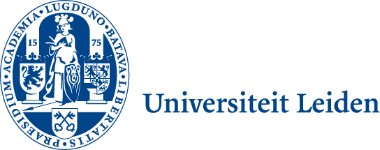 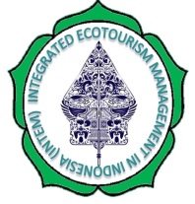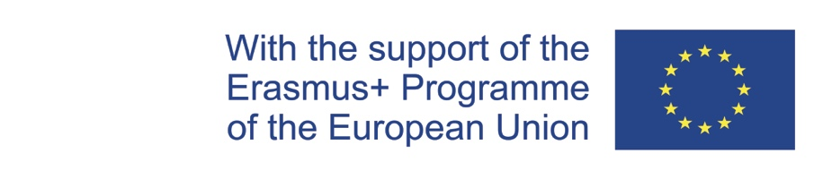

**INTEGRATED ECOTOURISM MANAGEMENT IN INDONESIA (INTEM)**

**Secretariat Project Coordination**

**Leiden Ethnosystems And Development Programme (LEAD)**

**Faculty of Science**

Van Steenis Building TO: The Representative of the

Einsteinweg 2, Co-Beneficiary Institution of the INTEM

The Netherlands Project Consortium

Tel.: +31-71-5273590/3591 The Netherlands, Greece & Indonesia

Email: <l.j.slikkerveer@gmail.com>

Leiden, 12 February 2019

Ref.: INTEM Project Information Sheet No. 1

Dear Project Partners,

After a prolonged and rather complicated validation process, which lasted up until Christmas of last year, I am very happy to inform you that eventually, the actual green light for our INTEM Project has formally been given by the Education, Audiovisual and Culture Executive Agency (EACEA) of the EU on the originally planned starting date of 15 January 2019.

As I also informed the Project Officers in Brussel, this process has for all of us in fact already been a project in itself, and I am very pleased that the unflagging perseverence of most of our partners since August of last year have eventually led to the final declaration of their eligibility as a partner of the INTEM Project, based on our common mission to complete the envisaged Master Programme in Integrated Ecotourism Management in Indonesie most successfully.

Such EU eligibility of all our partners is not only of great importance for your institution for formal cooperation with the European Union in Brussels, but also for our INTEM Project Consortium.

As the procedure had dragged on until mid-January, the Grant Agreement has eventually been signed head over heels on 21 January 2019 by the Legal Representative of the Erasmus Plus Programme in Brussel Mr. Ralf Rahders, Head of Unit A4 of EACEA, and the Legal Representative of Leiden University in Leiden Prof.mr. Carel Stolker, Rector of Leiden University, rendering the document only recently available for our Project.

I feel as such most priviledged to send you today as Project Coordinator to you in your position as the Representative of our Project Partner in the attachment a scanned copy of the Grant Agreement and related Annexes, as I have just received them from the EACEA in Brussels.

As you may notice, in this officially signed document and its Annexes, the position of your institution as a full partner and that of the selected participants of your institution to participate in the Project are legally defined and as such well established to contribute to the successful implementation of the Project during the project life cycle of 36 months since 15 January 2019.

-2-

In this document Leiden University is legally defined as the coordinating institution, while I am similarly legally defined as the Project Coordinator/Contact Person who is responsible for the project management during the project life cycle of 36 months as indicated above.

In the meantime, Mr. Kurniawan Saefullah MEc and I have recently been participating in the *Grant Holders Meeting* in Brussels of 28 and 29 January, where we have followed several intensive workshops and discussion groups on the administrative and financial management of our Project, showing that the management and accountability of all our actions and expenditures will be closely guided and monitored in a rather transparant way, based on several models and templates of the EU.

This implies that we will indeed need now to hold our joint first ‘kick-off’ meeting to familiarise ourselves with the complex procedures, administrative protocols and financial details in order to reach our objectives.

Following the informal consultations and meetings with the Representatives of our Indonesian partners in Bandung and Jakarta of last November, the principally agreed date for the ‘kick-off’meeting in Bandung has been set to take place from 1-10 April forthcoming, enabling us still to comply with the EU regulation that we have to hold such constituent meeting within the time span of 3 months from the official starting date onwards, despite the delay as mentined above.

As we also discussed last November in Bandung and Jakarta informally, the ‘kick-off’ meeting in Bandung will in principle be held at the Faculty of Economics and Business of Universitas Padjadjaran (UNPAD) in Bandung, where the Dean has been so kind as to offer us a meeting room in the Faculty Building. We then also hope to visit Universitas Pendidikan Indonesia (UPI), being our other counterpart in Bandung.

As you may understand from the enclosed scanned Grant Agreement, there is a budget provided for all the project activities of the 20 registered participants of the 8 partners/beneficiaries of the Project for the coming 3 years, which also include travel and accommodation costs, calculated by the EU as maximum ‘unit costs’ according to the financial tariffs prescribed by the EU.

For the envisaged ‘kick-off’ meeting, this means that the budget allows the provision of your travel costs and that of your colleagues as the registered participants of TST of the Project from your hometown to Bandung, and the costs of the hotel accommodation for you and your two colleagues for the envisaged 10 days from 1 April onwards, where we have made an attractive deal with the management of Grand Hotel Preanger for all participants who are coming from outside Bandung.

While I hope to work out a Programme and an agenda for the ‘kick-off’ meeting in Bandung to send to you soonest, I request you to make now your arrangements for Bandung where I will pay the above mentioned the costs on presentation of your paid invoices.

During the ‘kick-off’ meeting in Bandung we will not only discuss the content of the Project and related activities and inputs, but also consider in detail the future arrangements for the pre-financing of the costs which you atre expected to make for the Project in the form of the provision of a deposit of a part of the budget allocated to you as partner/beneficiary, which the financial manager of your institution will accept as eligble costs as defined by the EU, and as such declare these costs in the budget of your institution.

Such arrangements have to be further discussed and eventually established in the *‘Partnership Agreement’*, for which I also enclose the template in the *Guidelines* of the Erasmus Plus Capacity Building Pogramme for Higher Education (E+CBHE) of the EACEA.

-3-

In this context, in Art. 1.10.5 on page 7 of the Grant Agreement is indicated: *‘This partnership agreement should be consistent with the provisions as laid out in this Agreement. The Agency provides a template with core elements that might help to draw this partnership agreement. Agreement number: «NO_REF» Multi beneficiaries model agreement: October 2016 8. A signed copy of this partnership agreement will have to be provided by e-mail to the Agency within 6 months of the signature of this Agreement. Where the beneficiaries have failed to submit this partnership agreement, the provisions set out in Article II.16.3.1 (c) of the General Conditions will apply.’*

By consequence, this Partnership Agreement, together with its Annexes, has to be duly completed with the relevant Annexes and undersigned for the EU at the conclusion of the the ‘kick-off’ meeting in Bandung.

Furthermore, among the activities which we will jointly undertake during the ‘kick-off’ meeting are the establishment of several Project Commissions and the formulation and undersigning of a joint *Memorandum of Understanding* concerning the further implementation of the Project.

Since we wish to express, promote and disseminate our EU-supported Project as much as possible, I will not only design the INTEM logo soonest to appear next to the obligatory EU logo being the EU Flag with the indication of the text *‘With the support of the Erasmus + Programme of the European Union’,* but also hereby ask your permission –and that of all 7 partners - to show a small version of the logo of your institution with the caption at the bottom of our official A4 letter.

As I regard it a privilege to show all our institutions’ logo’s on our stationary next to that of the European logo, I will be pleased to first send you a draft for your final permission.

Finally, I am very pleased to inform you, that the Head of EACEA, Mr. Ralf Rahders and a Project Officer of the EU are very interested in our innovative Project, and as such are planning to come to Bandung and visit us during the ‘kick-off’ meeting, which I indeed regard as a great honour for all of us. Their visit to our meeting will further highlight the actual start of the Project and as such contribute to the official launching of the Project in the media in Indonesia.

I would highly appreciate if you could share this Project information with your colleagues as the other registered participants in the Project.

While I am looking forward to your kind reaction, I am sending you, also on behalf of my wife, our best greetings from Leiden.

With kind regards,

Prof.Dr. L. Jan Slikkerveer

INTEM Project Coordinator

**L. Jan Slikkerveer**

Draft INTEM logo

Annexes: - Grant Agreement

- Guidelines Partnership Agreement