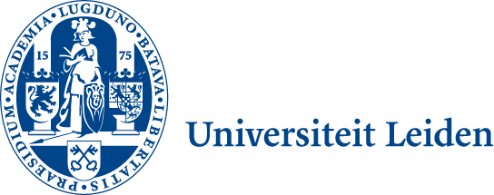  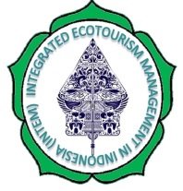 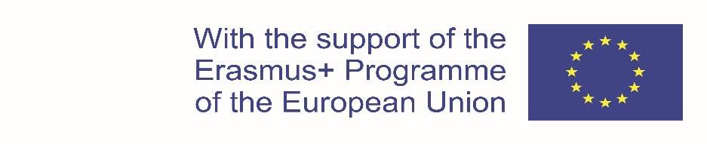

**INTEGRATED ECOTOURISM MANAGEMENT IN INDONESIA (INTEM)**

Project No. 599020-EPP-1-2018-1-NL International Capacity Building Higher Education-CBHE-JP

INTEM Project Coordination - Leiden Ethnosystems And Development Programme (LEAD)

Faculty of Science, Van Steenis Building, Einsteinweg 2, 2333 CC Leiden, The Netherlands

Primary Project Contact Coordinator: Prof.Dr. L. Jan Slikkerveer Email: [l.j.slikkerveer@gmail.com](mailto:l.j.slikkerveer@gmail.com)

**Deliverable 3.5** represents the Report of the Final Programme of the innovative curriculum on Integrated Ecotourism Management, prepared by all partners.

International Project Meeting of the EU project on INTEM in Chania, Crete (INTEM)

**Annex**: Doc. 3.5.1.

**INTERNATIONAL**

**MEETING OF THE JOINT PROJECT ON**

**INTEGRATED ECOTOURISM MANAGEMENT IN INDONESIA (INTEM)**

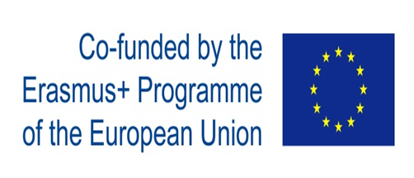



**Prof.Dr. L. Jan Slikkerveer, Coordinator (PCoCo)**

**LEAD-Leiden University, The Netherlands**

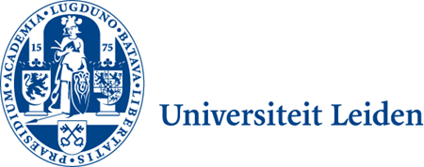

Discussions of the Course Contents and Course Design,

in combination with the advanced Education and Training Methods and Materials have pertained to the Final Pro-gramme of the Innovative Curriculum of the new Master Course on Integrated Ecotourism Management in Indonesia:

* Framework of 12 months
* 3 Core themes
* 4 Trimesters
* 8 Modules
* Theoretical and practical education

Linking up with the academic calendar of the executing partner institutions in Indonesia, the final INTEM Master Course combines the building blocks of the curriculum with the 3 core themes of:

*- INTEGRATED ECOTOURISM*

*- COMMMUNITY-BASED MANAGEMENT*

*- SUSTAINABLE TOURISM DEVELOPMENT*

*Providing an innovative programme on Integrated Ecotourism Management in Indonesia (INTEM), as is represented the Final Programme of the Innovative Curricuum of INTEM as follows:*

